www.georgiatestpractice.com
(All standards are the property of the Georgia Department of Education and can be accessed publicly at www.georgiastandards.org)

3rd Grade Social Studies CRCT Multiple Choice Questions
Highlight, use ctrl-c to copy and ctrl-v to paste into your own word documents.
Use ctrl-f to search for terms or standards.

SS3H1 The student will explain the political roots of our modern democracy in the United States of America.
a. Identify the influence of Greek architecture (columns on the Parthenon, U. S. Supreme Court building), law, and the Olympic Games on the present.

How is the U.S. Supreme Court building similar to the Parthenon in Greece?
- Both buildings are located in Greece.
- Both buildings have similar style columns
- The Supreme Court building was built in Greece
- The Supreme Court building was built by the same builders as the Parthenon
(correct answer B)

Which is something ancient Greece and the modern United States BOTH believe?
- Laws are important
- People should not vote
- Buildings should not have columns
- Leaders should be chosen by kings
(correct answer A)

SS3H1 The student will explain the political roots of our modern democracy in the United States of America.
b. Explain the ancient Athenians’ idea that a community should choose its own leaders.

According to the ancient Athenians, who should choose the leaders of a community?
- the community itself
- a king selected by birth
- people in another country
- the existing rulers should choose
(correct answer A)

SS3H1 The student will explain the political roots of our modern democracy in the United States of America.
c. Compare and contrast Athens as a direct democracy with the United States as a representative democracy.

If the citizens of a country vote on laws instead of for people, which type of democracy do they have?
- direct
- monarch
- dictatorship
- representative
(correct answer A)

In what way is the United States’ democracy different from democracy in Athens, Greece?
- People in United States democracy do not vote at all.
- Democracy in the United States is only used some of the time
- The United States elects representatives instead of voting on laws directly
- Leaders in Athens were selected to vote on laws and in the United States people do not vote
(correct answer C)

SS3H2 The student will discuss the lives of Americans who expanded people’s rights and freedoms in a democracy.
a. Paul Revere (independence), Frederick Douglass (civil rights), Susan B. Anthony (women’s rights), Mary McLeod Bethune (education), Franklin D. Roosevelt (New Deal and World War II), Eleanor Roosevelt (United Nations and human rights), Thurgood Marshall (civil rights), Lyndon B. Johnson (Great Society and voting rights), and César Chávez (workers’ rights).

Paul Revere is associated with which historical event?
- the Civil Rights movement
- the Worker’s Rights movement
- education and Women’s Rights
- independence and the American Revolution
(correct answer D)

Which event shows that Mary McLeod Bethune was dedicated to education?
- She started a school for African American girls
- She attempted to get women the right to vote
- She often participated in the United Nations
- She supported Franklin Roosevelt for president
(correct answer A)
Which item BEST completes the chart above?
- civil rights
- worker’s rights
- women’s rights
- education rights
(correct answer A)

Which item BEST completes the chart above?
- Education
- Independence
- The New Deal
- Worker’s Rights
(correct answer C)

Which award would be BEST to give to Susan B. Anthony?
- “Most Popular Person”
- “Leader of American Independence”
- “Best Supporter of Worker’s Rights”
- “Greatest Women’s Accomplishment”
(correct answer D)

SS3H2 The student will discuss the lives of Americans who expanded people’s rights and freedoms in a democracy.
b. Explain social barriers, restrictions, and obstacles that these historical figures had to overcome and describe how they overcame them.

In order for Thurgood Marshall to succeed as a lawyer and Supreme Court justice, which obstacle did he have to overcome?
- independence
- the right to vote
- lack of education
- segregation
(correct answer D)

Use the following list to answer question #___:
- Giving speeches at Women’s conventions
- Starting Women’s Organizations
- Publishing a women’s rights journal

The items in the list above were ways Susan B. Anthony tried to overcome which social barrier for women?
- the right to vote
- the right to own land
- the right to free speech
- the right to get the New Deal
(correct answer A)

SS3G1 The student will locate major topographical features.
a. Identify major rivers of the United States of America: Mississippi, Ohio, Rio Grande, Colorado, Hudson.
Use the following map to answer question #___:
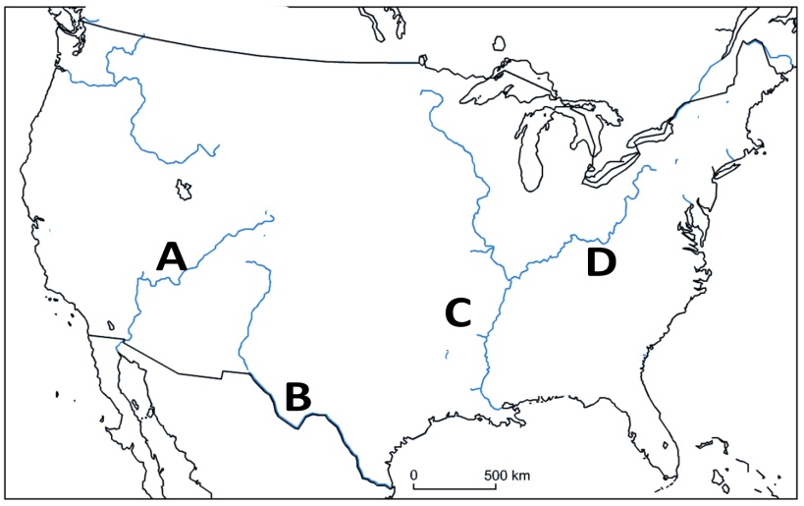

Which letter on the map above identifies the location of the Mississippi River?
- A
- B
- C
- D
(correct answer C)

Use the following map to answer question #___:

Which letter on the map above identifies the location of the Ohio River?
- A
- B
- C
- D
(correct answer D)

Use the following map to answer question #___:

Which letter on the map above identifies the location of the Colorado River?
- A
- B
- C
- D
(correct answer A)

Use the following map to answer question #___:

Which letter on the map above identifies the location of the Rio Grande?
- A
- B
- C
- D
(correct answer B)

SS3G1 The student will locate major topographical features.
b. Identify major mountain ranges of the United States of America: Appalachian, Rocky.

Use the following map to answer question #___:
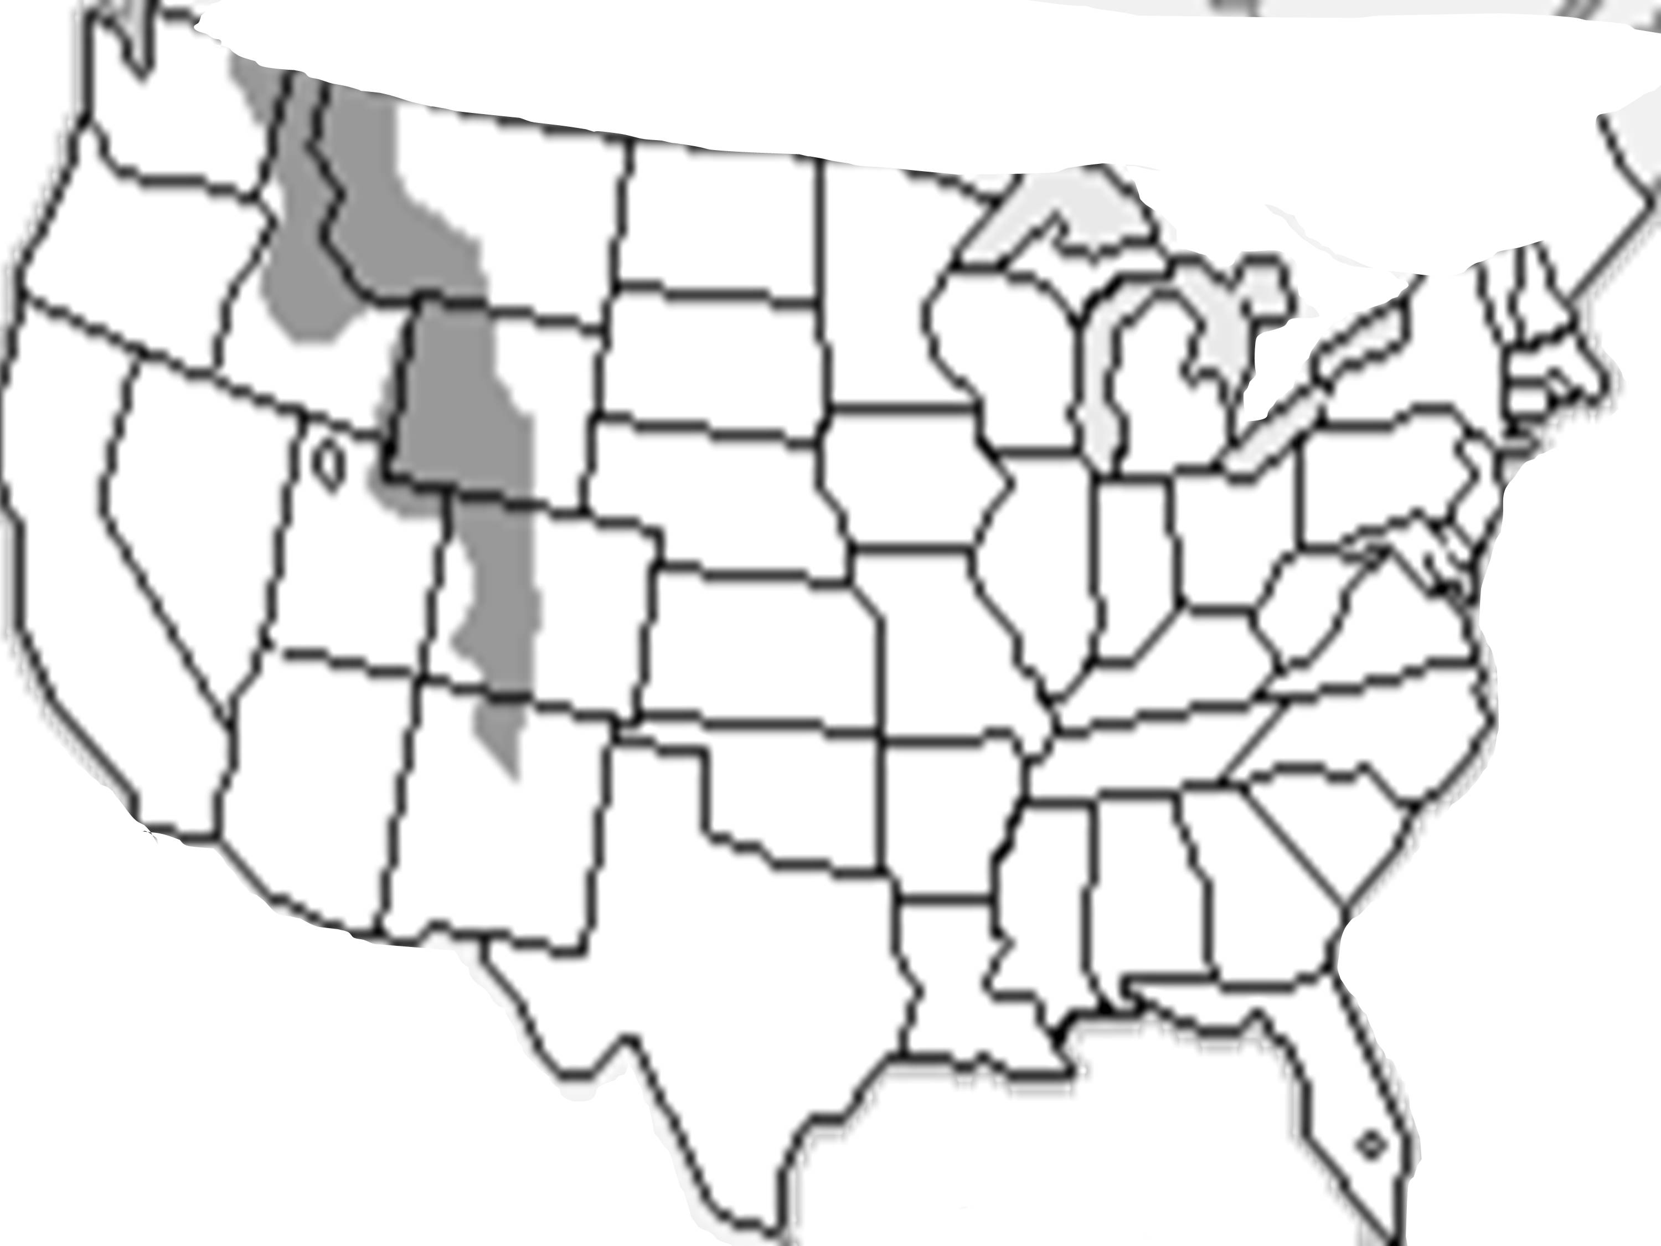
The dark, shaded region on the map represents which physical feature of the United States?
- the Rio Grande
- the Mississippi River
- the Rocky Mountains
- the Appalachian Mountains
(correct answer C)

Use the following map to answer question #___:
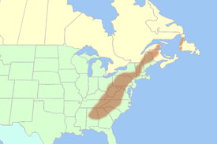
The dark, shaded region on the map represents which physical feature of the United States?
- the Rio Grande
- the Mississippi River
- the Rocky Mountains
- the Appalachian Mountains
(correct answer D)

SS3G1 The student will locate major topographical features.
c. Locate the Equator, Prime Meridian, and lines of latitude and longitude on a globe.

Use the following picture to answer question #___:
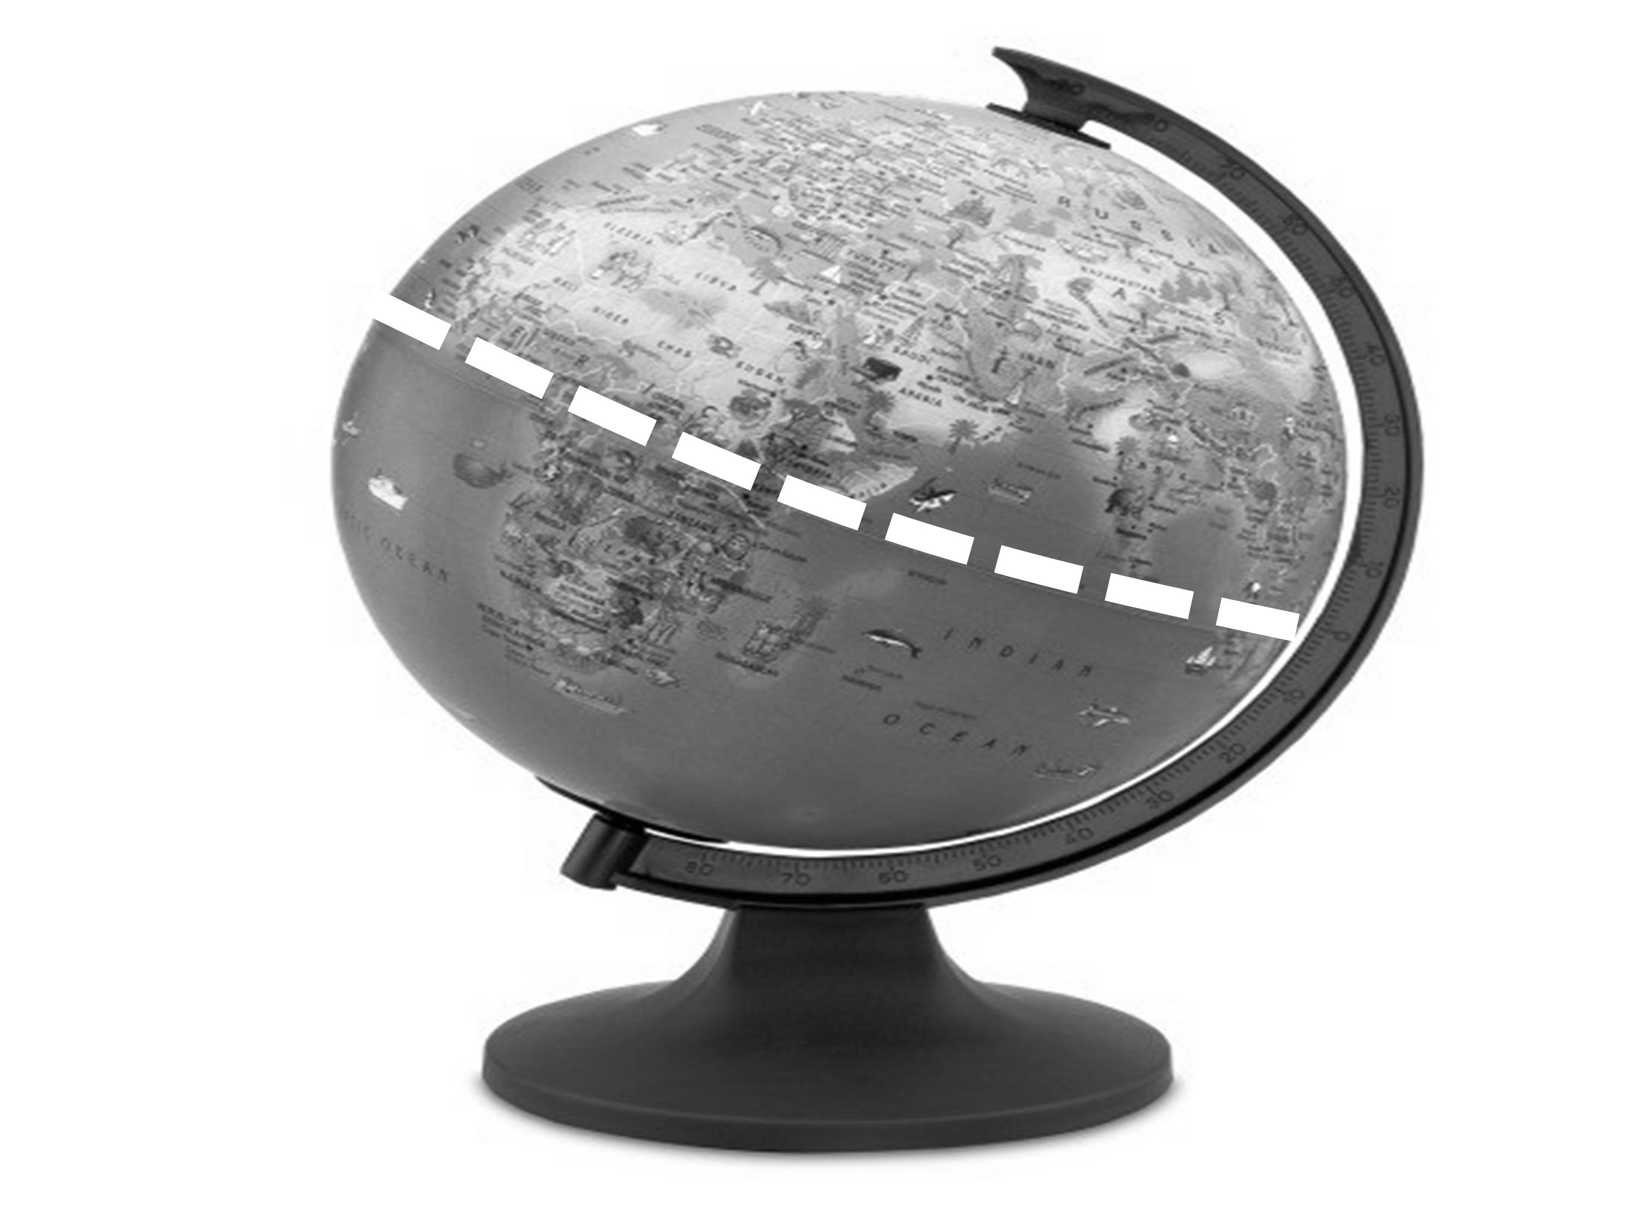
The dashed line on the center of the globe above represents which feature?
- the equator
- the Prime Meridian
- the Mississippi River
- the main longitude line
(correct answer A)

Which imaginary lines run north and south and help measure distance around the globe?
- rivers
- equator
- latitude
- longitude
(correct answer D)

SS3G1 The student will locate major topographical features.
d. Locate Greece on a world map.

SS3G2 The student will describe the cultural and geographic systems associated with the historical figures in SS3H2a.
a. Identify on a political map specific locations significant to the life and times of these historical figures.

The letter X on the map above shows a location that was MOST significant to which individual?
- Paul Revere
- Cesar Chavez
- Mary Bethune
- Frederick Douglass
(correct answer B)

Use the following map to answer question #___:
The map above MOST LIKELY shows the actions of which person?
- Paul Revere
- Susan Anthony
- Franklin Roosevelt
- Thurgood Marshall
(correct answer A)

SS3G2 The student will describe the cultural and geographic systems associated with the historical figures in SS3H2a.
b. Describe how place (physical and human characteristics) had an impact on the lives of these historical figures.

How did life in the New England colonies affect Paul Revere?
- It made him want to go back to England
- He was around others who wanted independence.
- His job was only useful in the New England Colonies.
- He felt it was the best place to tell people about the New Deal.
(correct answer B)

Which geographic factor played a significant role in the life of Cesar Chavez?
- Where he lived was very cold
- Where he lived was very hot
- He was raised in a big city with skyscrapers
- He was raised near farms with farm workers
(correct answer D)

SS3G2 The student will describe the cultural and geographic systems associated with the historical figures in SS3H2a.
c. Describe how each of these historical figures adapted to and was influenced by his/her environment.

Which BEST describes how Cesar Chavez influenced his environment?
- He was able to end slavery on the farms near where he worked.
- He listened to what farmers wanted and used that in his leadership.
- Since there were no farming jobs, Cesar began inventing new products.
- Since the area was poor, he was able to get power by paying the leaders.
(correct answer B)

How did Frederick Douglas’ experience in the south influence his life?
- it made him want to move west
- he moved north to escape slavery
- where he lived had no effect on his life
- he enjoyed the south, so he stayed there
(correct answer B)

SS3G2 The student will describe the cultural and geographic systems associated with the historical figures in SS3H2a.
d. Trace examples of travel and movement of these historical figures and their ideas across time.

Mary McLeod Bethune visited multiple places during her life. Which idea did she always promote in each place she visited?
- women’s voting rights
- Greek democracy was best
- a good education for everyone
- support for American independence
(correct answer C)

SS3G2 The student will describe the cultural and geographic systems associated with the historical figures in SS3H2a.
e. Describe how the regions in which these historical figures lived affected their lives and had an impact on their cultural identification.

Which geographic region did Franklin Roosevelt prefer for its warmer weather and warm springs?
- Southeast
- Southwest
- Northwest
- Northeast
(correct answer A)

SS3CG1 The student will explain the importance of the basic principles that provide the foundation of a republican form of government.
a. Explain why in the United States there is a separation of power between branches of government and levels of government.

Which concept prevents one branch of Government from getting too powerful in the United States?
- the county commission
- Athenian democracy
- diligence and justice
- separation of powers
(correct answer D)

In the United States power in Government is divided in two ways: between the three branches of government and which other way?
- between east and west
- between national and state levels
- between states and other countries
- between the economy and the government
(correct answer B)

SS3CG1 The student will explain the importance of the basic principles that provide the foundation of a republican form of government.
b. Name the three levels of government (national, state, local) and the three branches in each (executive, legislative, judicial), including the names of the legislative branch (Congress, General Assembly, county commission or city council).

Use the following chart for question #___:

In the chart above, which level of government is missing?
- National
- Congress
- Executive
- Judicial
(correct answer A)

At the national level, the legislative branch of government is called Congress. What is the legislative branch called in Georgia?
- Supreme Court
- General Assembly
- Georgia’s Governor
- Local Governments
(correct answer B)

What are the three branches of the national government?
- Local, State, Region
- City, State, Country
- Legislative, Executive, Judicial
- Congress, General Assembly, City Council
(correct answer C)

SS3CG1 The student will explain the importance of the basic principles that provide the foundation of a republican form of government.
c. State an example of the responsibilities of each level and branch of government.

Jim says to Sally, “I like the President because he makes laws.”
Sally replies, “No, he enforces laws. It is Congress that makes laws.”
Which person is correct in this discussion?
- Jim
- Sally
- Both
- Neither
(correct answer B)

Congress passes a bill and the President signs it, making it a law. If people thought the bill was not fair and unconstitutional, what would be the BEST way to get it changed?
- Try to get the President to erase his signature.
- Nothing, once a law is passed, it is a law forever.
- Ignore the law and pretend it never existed in the first place.
- Take a case to the Supreme Court for them to interpret the law.
(correct answer D)

SS3CG2 The student will discuss the character of different historical figures in SS3H2a.
a. Describe how the different historical figures in SS3H2a display positive character traits of cooperation, diligence, courage, and leadership.

Thurgood Marshall’s hard work and long hours spent on his court cases BEST demonstrates which character trait?
- diligence
- tolerance
- freedom
- respect
(correct answer A)

Cesar Chavez was displaying which character trait when he started the United Farm Workers Movement?
- laziness
- loveable
- leadership
- liberty
(correct answer C)

SS3CG2 The student will discuss the character of different historical figures in SS3H2a.
b. Explain how the historical figures in SS3H2a used positive character traits to support their beliefs in liberty, justice, tolerance, and freedom of conscience and expression.

Lyndon Johnson signed laws like the Voting Rights Act and the Civil Rights Act because of his strong belief in which character trait?
- justice
- authority
- inequality
- intolerance
(correct answer A)

SS3CG2 The student will discuss the character of different historical figures in SS3H2a.
c. Explain how the historical figures in SS3H2a chose when to respect and accept authority.

Susan B. Anthony voted for President in the ___ election. Soon after, she was arrested for voting because she was not allowed to. She went to jail briefly and appeared at all of her court appearances. By doing these things, how was Susan B. Anthony responding to authority?
- with cooperation and natural resources
- with respect and acceptance
- with tolerance and liberty
- with expression and fun
(correct answer B)

Which action shows that Mary McLeod Bethune respected and accepted authority?
- she consistently wanted to change policies
- she served at the White House when asked
- she made her own schools with her own rules
- she started several organizations to challenge laws
(correct answer B)

SS3E1 The student will describe the four types of productive resources:
a. Natural (land)

Use the following information and pictures for question #___:
Susan runs a restaurant that makes breakfast and baked goods.

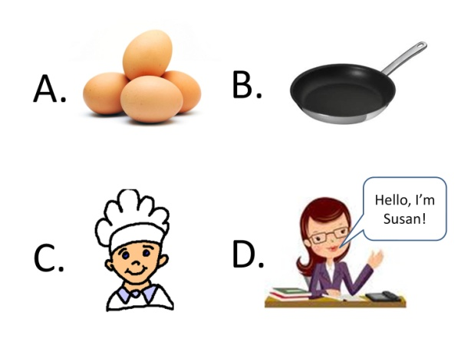
Which picture represents the productive resource known as a natural resource?
- A
- B
- C
- D
(correct answer A)

SS3E1 The student will describe the four types of productive resources:
b. Human (labor)

Use the following information and pictures for question #___:
Susan runs a restaurant that makes breakfast and baked goods.

Which represents the productive resource known as human resource?
- A
- B
- C
- D
(correct answer C)

SS3E1 The student will describe the four types of productive resources:
c. Capital (capital goods)

Use the following information and pictures for question #___:
Susan runs a restaurant that makes breakfast and baked goods.

Which represents the productive resource known as capital?
- A
- B
- C
- D
(correct answer B)

SS3E1 The student will describe the four types of productive resources:
d. Entrepreneurship (used to create goods and services)

Use the following information and pictures for question #___:
Susan runs a restaurant that makes breakfast and baked goods.

Which represents the productive resource known as entrepreneurship?
- A
- B
- C
- D
(correct answer D)

SS3E2 The student will explain that governments provide certain types of goods and services in a market economy, and pay for these through taxes and will describe services such as schools, libraries, roads, police/fire protection, and military.

Use the following list to answer question #___:
- public schools
- public libraries
- police stations
- fire departments
- military operations
All of the items in the list above have what in common?
- They are all run by businesses
- They are all natural resources
- They are all owned by children
- They are all paid for with taxes
(correct answer D)

SS3E3 The student will give examples of interdependence and trade and will explain how voluntary exchange benefits both parties.
a. Describe the interdependence of consumers and producers of goods and services.

Which two groups are dependent on each other to exchange goods and services?
- consumers and producers
- countries and states
- adults and children
- businesses and sellers
(correct answer A)

What is MOST LIKELY to happen to a good if consumers stop buying it?
- producers will produce less
- producers will produce more
- producers will make more money
- producers will produce the same amount
(correct answer A)

SS3E3 The student will give examples of interdependence and trade and will explain how voluntary exchange benefits both parties.
b. Describe how goods and services are allocated by price in the marketplace.

What piece of information tells producers how much of a good to make and consumers how much of a good they can buy?
- their parents
- the price of the item
- what it cost to make the item
- how many people are buying the item
(correct answer B)

If the price of an item increases, which group of people will benefit?
- producers of the item
- consumers of the item
- governments who buy the item
- other countries who buy the item
(correct answer A)

SS3E3 The student will give examples of interdependence and trade and will explain how voluntary exchange benefits both parties.
c. Explain that some things are made locally, some elsewhere in the country, and some in other countries.

Mary lives in the city and there are no berry farms nearby. Yet, when she gets to the grocery store in the city, there is a variety of strawberries, blueberries, and raspberries. Which conclusion can you draw from this information?
- Mary is probably dreaming because she can’t really get berries.
- Mary drives a long way to get to a grocery store that has berries.
- The berries are produced somewhere else and shipped to Mary’s store.
- The berries she is seeing are probably fake berries that don’t taste good.
(correct answer C)

Goods and services can be produced in three places. Which list below BEST identifies these three places?
- farms, cities, islands
- workers, producers, businesses
- the government, businesses, people’s houses
- locally, in different parts of the United States, in other countries
(correct answer D)

SS3E3 The student will give examples of interdependence and trade and will explain how voluntary exchange benefits both parties.
d. Explain that most countries create their own currency for use as money.

When countries trade with other countries, they create their own _____, which is used as money, to make trade easier. What word would BEST fit in this blank?
- trade
- markets
- currency
- government
(correct answer C)

SS3E4 The student will describe the costs and benefits of personal spending and saving choices.

Polly is saving money for a new toy. Which is a cost she is giving up to get the new toy?
- spending her money on something now
- the fun she will have with the new toy
- nothing because she still has her money
- not knowing when the new toy will break
(correct answer A)

If a person spends money today to buy an item, what have they lost?
- the price of the item
- the benefit of saving money
- the item on which they spent the money
- the ability to get something with the money
(correct answer B)

